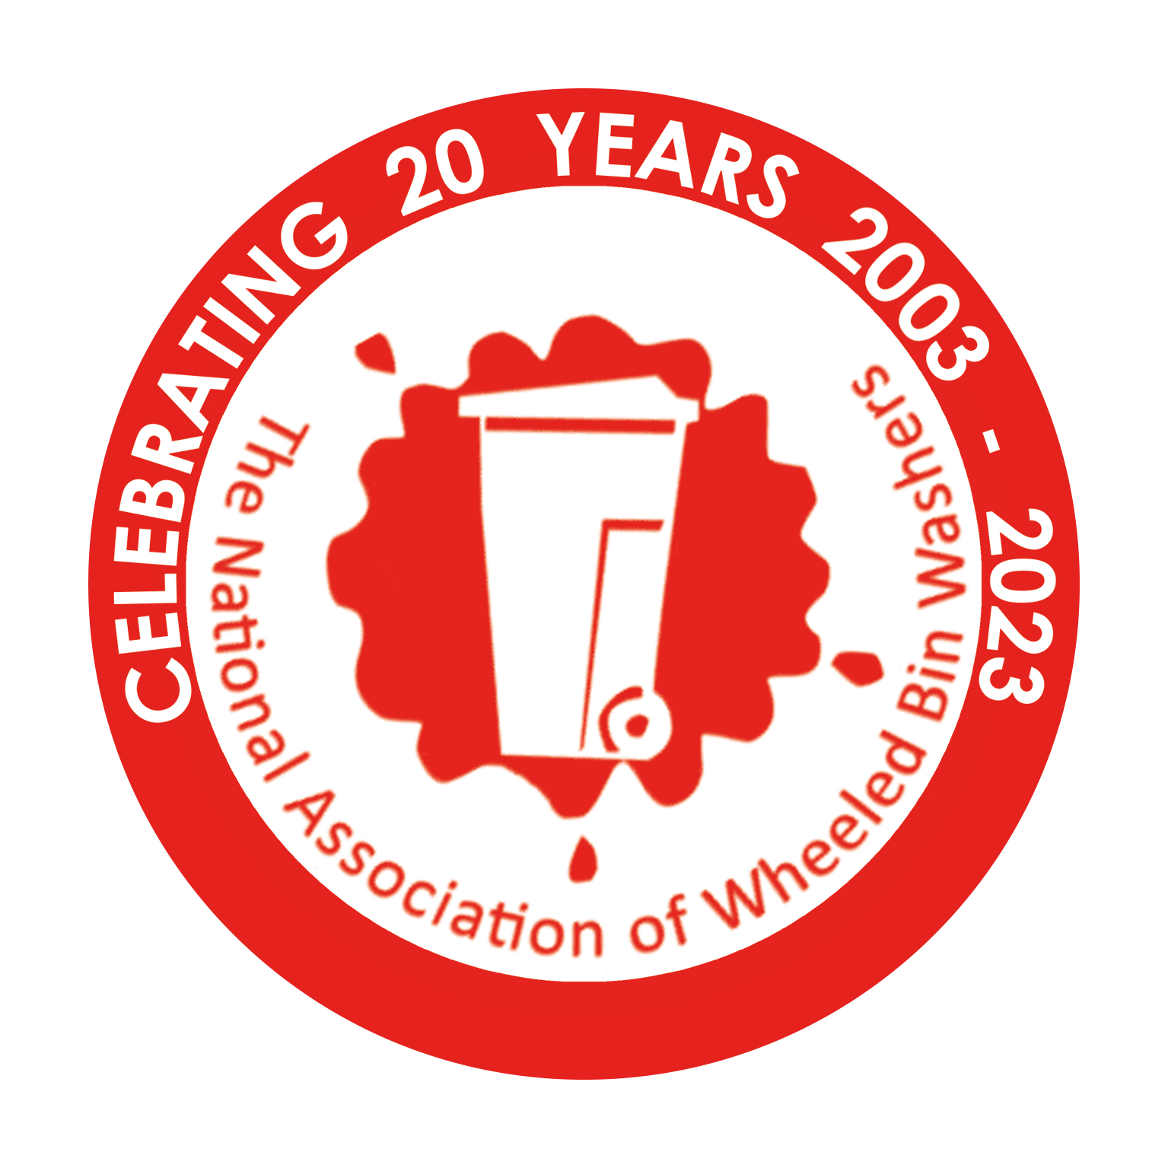
The National Association of
Wheeled Bin Washers
Application for membership of:
The National Association of Wheeled Bin Washers

Company Name: ________________________________________________

Company Address: _________________________________________________

_________________________________________Postcode: _______________

Company Registered Number (If applicable): _____________________________

Company VAT Registered Number (If applicable): _________________________

Telephone Number: Office: ____________________ Mobile: _______________

Fax Number: _______________________________________________

Email Address: _______________________________________________

Website Address: _______________________________________________

Company Representatives Name: _____________________________________

Position within company: ____________________________________________

Description of ALL bin washing equipment: (you MUST please supply a photograph or diagram):

DECLARATION ON BEHALF OF THE COMPANY:

I ____________________________ on behalf of ___________________________ and being duly eligible to act on the companies behalf, agree that this company will comply in full with the guidelines laid out in the associations Charter and Health & Safety guidelines booklet.

I confirm that the company has the following (copies MUST be sent with this form):

- Lower Tier Waste Carriers Licence from the Environment Agency.
(Please supply the registration number).
- Water Authorities “legal consent for discharge of effluence”.
(Please supply a copy of the Certificate).
c) Employee/public liability and vehicle insurance. (Please supply a copy of the certificate).
d) Authority from the local authority to wash their bins.
(Please supply a copy of your letter to them and/or their reply)
NOTES:
THE MEMBERSHIP FEE IS A ONE-OFF, PAYMENT OF £120.
Members are permitted to display the association’s logo and name on their vehicles and stationery (including leaflets and websites).
The association logo may be displayed either in black or bright red only.
The Association is known to and registered with the Environment Agency, The Water Authorities in most regions, and DEFRA as well as many local and county councils.
Any member found to be breaking the association’s Charter or Health & Safety guidelines will have their membership cancelled with immediate effect.
The association works on behalf of its members and any help it can give you in the regulation of our industry will be forthcoming by contacting the association directly.

The National Association of Wheeled Bin Washers Limited
Units 1-2 Ladfordfields Industrial Park, Stafford, Staffordshire, ST18 9QE
Telephone: (01785) 281308 Fax: (01785) 281300
email: info@nawbw.co.uk Website: www.nawbw.co.uk

